**Temperature**

**Requirements:**

* **Java Code**
* **NetBeans IDE**
* **Documentation**

**Groupmates:**

NAME : Jhon Brix G. Brion – CS Student, Java Program Developer.  
NAME : Shane Marie Mon – CS Student, Java Program Documentation.

**Lecture Activity Problem:**

1. Create a program that will get the user temperature and convert it to Celsius and Fahrenheit.

Requirements:

* + Use Action Event and Listener (Event Programming)
  + TextField
  + Buttons

Grade Matrix:

Code : 50%

Documentation : 50%

100%

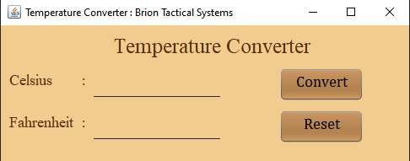**JAVA PROGRAM RUNTIME**  
  
  
  
  
  
  
  
  
  
  
  
  
Figure 1. Temperature Converter Runtime.

Figure 1 shown here is the final output of the Temperature converter, which is composed of a JPanel for the color of the background, three JLabels for the Program name, celsius label, and fahrenheit label. As well as two JTextfields for user Input but only the Celsius text field is used to convert Celsius to Fahrenheit, it can not be converted vice versa. Lastly, two JButtons “Convert” to execute the Action Listener and convert the numbers inputted by the user, and the Reset JButton, which resets the JTextfields.

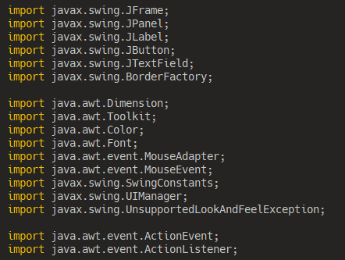**JAVA PROGRAM SOURCE CODE**

Figure 2.1. Java Imports.

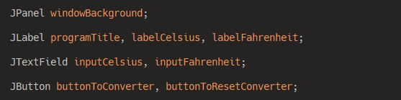 Figure 2.1 shows the imports used in the Java program.

Figure 2.2. Swing Component Declaration.

Figure 2.2 show the declared Swing Components as Local Variables. the Swing components are composed of the following :

* **windowBackground (JPanel)** – This component covers the entire JFrame, as well as change the color for custom background.
* **programTitle (JLabel)** – This component creates a label and sets the program’s label.

* **labelCelsius (JLabel)** – This component sets the label of the Celsius alongside the ***inputCelsius (JTextfield).***
* **inputCelsius (JTextField)** – This component is used to get the user’s input for the temperature of Celsius.
* **labelFahrenheit (JLabel)** – This component sets the label of the Fahrenheit alongside the ***inputFahrenheit (JTextField).***
* **inputFahrenheit (JTextField) –** This component is used to display the converted Celsius into Fahrenheit.
* **buttonToConverter (JButton)** – This component is used to execute the Action Listener and convert the Celsius temperature into Fahrenheit and display it on the ***inputFahrenheit (JTextField).***
* **buttonToResetConverter (JButton)** – This Component is used to reset the JTextFields ***inputCelsius***and ***inputFahrenheit.***

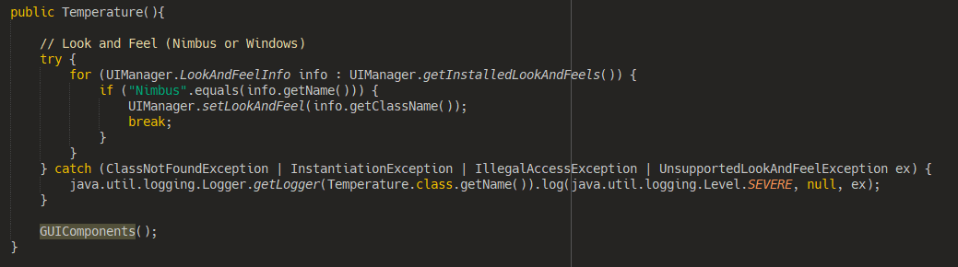 Figure 2.3. Method Block for executing the Methods used in the program.

Figure 2.3 shows the Method Block that is called to execute the methods included in the program. Inside this method, a Try-Catch Block which set the program’s Look and Feel. as of now the only working look and feel are as follows :

* **Default** – the windows XP like look and feel.
* **Nimbus** – The Java Look and feel.
* **Windows** – The modern Windows like look and feel. (depends on the Operating system version)

We used this method to call all other methods whenever the program is called from the main method. for short this method is used for method organization.

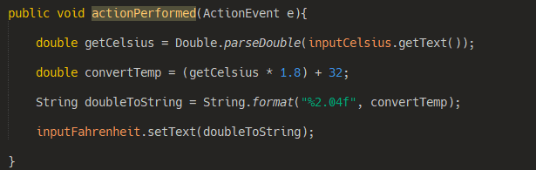Figure 2.4. ActionPerformed method block.

Figure 2.4 shows a method block of Action Event called by the Action Listener from the convert JButton present in the Method **GUIComponents().** This method is used to execute the conversion from Celsius to Fahrenheit.

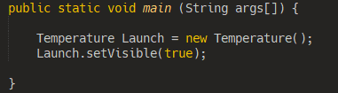   
  
  
  
  
 Figure 2.5. The Main Method.

Figure 2.5 shows the main method block with the Declaration and Instantiation of the Temperature Class, which extends into a JFrame. **“Launch.setVisible(true);”** is used for more controllability over the program execution and Visibility.

**JAVA SWING COMPONENTS SOURCE CODE**

This is the GUIComponent() Method’s Source code. This method is where the Java Swing Components are decorated and positioned from the JFrame.

Source Code :

**public** **void** GUIComponents(){

*// Component Instantiation*

windowBackground = **new** JPanel();

programTitle = **new** JLabel();

labelCelsius = **new** JLabel();

labelFahrenheit = **new** JLabel();

inputCelsius = **new** JTextField();

inputFahrenheit = **new** JTextField();

buttonToConverter = **new** JButton();

buttonToResetConverter = **new** JButton();

*// JFrame Declaration*

**final** **int** FrameSizeX = 500;

**final** **int** FrameSizeY = 200;

*// JFrame Size.*

setSize(FrameSizeX, FrameSizeY);

setMinimumSize(**new** Dimension(FrameSizeX, FrameSizeY));

setPreferredSize(**new** Dimension(FrameSizeX, FrameSizeY));

*// JFrame Decoration.*

setUndecorated(**false**);

setOpacity(1.0f);

setTitle("Temperature Converter : Brion Tactical Systems");

setLayout(**null**);

setResizable(**true**);

setDefaultCloseOperation(JFrame.EXIT_ON_CLOSE);

*// CENTER POPUP MAIN WINDOW.*

Dimension dimension = Toolkit.getDefaultToolkit().getScreenSize();

setLocation(dimension.width / 2 - **this**.getWidth() / 2, dimension.height / 2 - **this**.getHeight() / 2);

*// Window Background (JPanel) Decorations.*

add(windowBackground);

windowBackground.setBounds(0, 0, 500, 200);

windowBackground.setBackground(**new** Color(242, 204, 143));

windowBackground.setLayout(**null**);

windowBackground.setVisible(**true**);

*// Program Title (JLabel) Decorations.*

windowBackground.add(programTitle);

programTitle.setBounds(65, 10, 370, 30);

programTitle.setForeground(**new** Color(88, 47, 14));

programTitle.setFont(**new** Font("Times New Roman", Font.PLAIN, 25));

programTitle.setHorizontalAlignment(SwingConstants.CENTER);

programTitle.setText("Temperature Converter");

programTitle.setVisible(**true**);

*// Label Celcius (JLabel) Decorations.*

windowBackground.add(labelCelsius);

labelCelsius.setBounds(10, 50, 150, 30);

labelCelsius.setForeground(**new** Color(88, 47, 14));

labelCelsius.setFont(**new** Font("Times New Roman", Font.PLAIN, 18));

labelCelsius.setHorizontalAlignment(SwingConstants.LEADING);

labelCelsius.setText("Celsius :");

labelCelsius.setVisible(**true**);

*// Input Celcius (JTextField) Decorations.*

windowBackground.add(inputCelsius);

inputCelsius.setBounds(110, 50, 150, 35);

inputCelsius.setBackground(**new** Color(0,0,0,0));

inputCelsius.setForeground(**new** Color(43, 45, 66));

inputCelsius.setOpaque(**false**);

inputCelsius.setCaretColor(**new** java.awt.Color(0,0,0));

inputCelsius.setBorder(BorderFactory.createMatteBorder(0, 0, 1, 0, **new** Color(43, 45, 66)));

inputCelsius.setFont(**new** Font("Cambria Math", Font.BOLD, 14));

inputCelsius.setVisible(**true**);*//*

*// Label Farenheight (JLabel) Decorations.*

windowBackground.add(labelFahrenheit);

labelFahrenheit.setBounds(10, 100, 200, 30);

labelFahrenheit.setForeground(**new** Color(88, 47, 14));

labelFahrenheit.setFont(**new** Font("Times New Roman", Font.PLAIN, 18));

labelFahrenheit.setHorizontalAlignment(SwingConstants.LEADING);

labelFahrenheit.setText("Fahrenheit :");

labelFahrenheit.setVisible(**true**);

*// Input Farenheight (JTextField) Decorations.*

windowBackground.add(inputFahrenheit);

inputFahrenheit.setBounds(110, 100, 150, 35);

inputFahrenheit.setBackground(**new** Color(0,0,0,0));

inputFahrenheit.setForeground(**new** Color(43, 45, 66));

inputFahrenheit.setOpaque(**false**);

inputFahrenheit.setCaretColor(**new** java.awt.Color(0,0,0));

inputFahrenheit.setBorder(BorderFactory.createMatteBorder(0, 0, 1, 0, **new** Color(43, 45, 66)));

inputFahrenheit.setFont(**new** Font("Cambria Math", Font.BOLD, 14));

inputFahrenheit.setVisible(**true**);*//*

*// Button to Execute Conversion (JButton) Decorations.*

windowBackground.add(buttonToConverter);

buttonToConverter.setBounds(330, 50, 100, 40);

buttonToConverter.setBackground(**new** Color(147, 102, 57));

buttonToConverter.setFont(**new** Font("Cambria Math", Font.PLAIN, 18));

buttonToConverter.setFocusPainted(**false**);

buttonToConverter.setHorizontalAlignment(SwingConstants.CENTER);

buttonToConverter.setVerticalAlignment(SwingConstants.CENTER);

buttonToConverter.setOpaque(**false**);

buttonToConverter.setForeground(**new** Color(0,0,0));

buttonToConverter.setText("Convert");

buttonToConverter.setVisible(**true**);

buttonToConverter.setContentAreaFilled(**true**);

buttonToConverter.setBorderPainted(**false**);

buttonToConverter.setIconTextGap(-2);

buttonToConverter.addActionListener(**this**);

buttonToConverter.addMouseListener(**new** MouseAdapter(){

@Override

**public** **void** mousePressed(MouseEvent e) {

buttonToConverter.setBackground(**new** Color(88, 47, 14));

buttonToConverter.setForeground(**new** Color(255,255,255));

}

@Override

**public** **void** mouseReleased(MouseEvent e) {

buttonToConverter.setBackground(**new** Color(147, 102, 57));

buttonToConverter.setForeground(**new** Color(0,0,0));

}

@Override

**public** **void** mouseEntered(MouseEvent e){

buttonToConverter.setBackground(**new** Color(127, 79, 36));

}

@Override

**public** **void** mouseExited(MouseEvent e){

buttonToConverter.setBackground(**new** Color(147, 102, 57));

buttonToConverter.setForeground(**new** Color(0,0,0));

}

});

*// Button to Reset Converter (JButton) Decorations.*

windowBackground.add(buttonToResetConverter);

buttonToResetConverter.setBounds(330, 100, 100, 40);

buttonToResetConverter.setBackground(**new** Color(147, 102, 57));

buttonToResetConverter.setFont(**new** Font("Cambria Math", Font.PLAIN, 18));

buttonToResetConverter.setFocusPainted(**false**);

buttonToResetConverter.setHorizontalAlignment(SwingConstants.CENTER);

buttonToResetConverter.setVerticalAlignment(SwingConstants.CENTER);

buttonToResetConverter.setOpaque(**false**);

buttonToResetConverter.setForeground(**new** Color(0,0,0));

buttonToResetConverter.setText("Reset");

buttonToResetConverter.setVisible(**true**);

buttonToResetConverter.setContentAreaFilled(**true**);

buttonToResetConverter.setBorderPainted(**false**);

buttonToResetConverter.setIconTextGap(-2);

buttonToResetConverter.addMouseListener(**new** MouseAdapter(){

@Override

**public** **void** mousePressed(MouseEvent e) {

buttonToResetConverter.setBackground(**new** Color(88, 47, 14));

buttonToResetConverter.setForeground(**new** Color(255,255,255));

inputCelsius.setText("");

inputFahrenheit.setText("");

}

@Override

**public** **void** mouseReleased(MouseEvent e) {

buttonToResetConverter.setBackground(**new** Color(147, 102, 57));

buttonToResetConverter.setForeground(**new** Color(0,0,0));

}

@Override

**public** **void** mouseEntered(MouseEvent e){

buttonToResetConverter.setBackground(**new** Color(127, 79, 36));

}

@Override

**public** **void** mouseExited(MouseEvent e){

buttonToResetConverter.setBackground(**new** Color(147, 102, 57));

buttonToResetConverter.setForeground(**new** Color(0,0,0));

}

});

}  
_____________________________________________________________________________

END OF SOURCE CODE